

**Mawlana Bhashani Science and Technology University**

**Project Report**

**Department:** Computer Science and Engineering

**Course Title:** Software Development Project-I and Industrial Tour

**Course Code:** CSE2112

**Submitted By Supervised By**

Wasif Bin Zahir Mohammed Hadifur Rahman

**ID:** CE20022 Associate Professor

**Session:** 2019-20 Department of CSE

MBSTU

**Project Title: Digital Appointment System**

**TABLE OF CONTENT**

|  |  |  |
| --- | --- | --- |
| **Index** | **Content** | **Page** |
| 1 | Introduction | 3 |
| 2 | Motivation | 4 |
| 3 | Objectives | 4 |
| 4 | Project description | 5 |
| 5 | Project features | 6-16 |
| 5 | Methodology and Implementation | 17-25 |
| 6 | Limitations | 25 |
| 7 | Future Possibilities | 26 |
| 8 | Conclusion | 26 |
| 9 | References | 27 |

**Introduction:**

Digital Appointment System is an appointment project designed for hospitals, consultation centers and diagnostic centers use. This application is a helpful tool for providing many hospital services to the patients that an ideal hospital provides commonly. Users can digitize those services with the use of this system.

Hospital service is rendered by doctors, nurses, paramedics, and many other employees working in a hospital. Doctors identify diseases and prescribe necessary treatments for patients. Conventionally, patients meet doctors to get treatment by booking appointments with doctors. Digital Appointment System provides a digitized platform where these appointment data can be stored and managed easily. This platform reduces all the conventional paperwork hassle for the management section of a hospital as those data can be digitally stored and used anytime when needed.

The data of appointed doctors are also important as they will be used while booking appointments. Using Digital Appointment System, users can also store data related to the doctors and access them for different use. In addition, this application also provides a feature to manage appointments for clinical medical tests. Thus, it creates a digitized platform to help providing many hospital services to the patients.

**Motivations:**

Paperwork has always been a hardship to face. Doing proper paper reports and managing them comes with a great cost of application too. A digitized solution like Digital Appointment System can reduce the hassles that conventional paperwork creates. It also reduces the cost of application and management. It is also much more efficient in terms of time. This system will ensure a digital appointment experience for the patient and a hassle-free workflow for the hospitals, consultation centers and diagnostic centers authority. This will also ensure secure data storage but further easy access for administrative users. The main motto of this system is to create a digital experience for patients to book appointments as fast as possible and as easy as possible and also ensure a smooth management experiment for the hospital authority.

**Objectives:**

The main objectives of this project are given below:

* To digitalize the appointment experience
* To maintain patient history
* To register a doctor digitally
* To maintain the medical test digitally

**Project Description:**

This project is mainly a digital appointment booking system which has been designed for hospitals, consultation centers and diagnostic centers s mainly. The expected user of this system is the hospitals, consultation centers and diagnostic centers authority. The system will provide services to patients and doctors as well. In this system, patients can book different types of appointments related to medical services. This system will also store the data about the registered doctors in a specific hospitals, consultation centers and diagnostic centers . These data can be accessed and updated after storing them in the system. They can be filtered by many different parameters when needed. This system can also book medical test data digitally for the patient prescribed by a specific doctor. As before user can also show the list of entire medical tests till date and can filter data by different parameters according to the need of the authority. This system has three major segments which are patient, doctor, and medical test. In the patient segment, the main features are creating an appointment, updating an appointment, filtering appointments by related parameters, and deleting appointments. Same as for the doctor segment. This system can register new doctors, update doctor details, and filter the doctor list according to the need. Another feature of the system is to maintain the medical test data. These data can be access if needed.

**Project Features:**

The main features of digital appointment system is given below

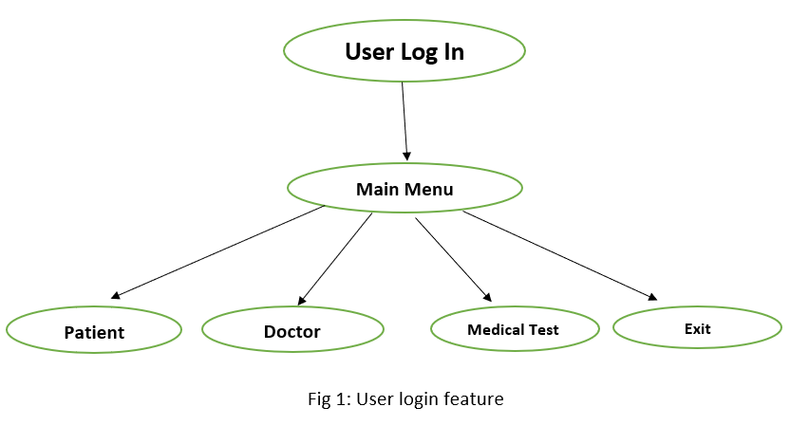

**User Login:**

After launching the program, users will get a sign-in window where they will have to log in with a pre-defined ID and a password in order to go forward and browse other features. User login is a compulsory step to go forward to the system and avail of the other services. This can consider as primary security for the system

**Main Menu:**

After login into the system, users will have to choose one option among four which are Patient, Doctor, Medical Test, and Exit. The patient appointment section is all about the patients. Here, users can create new appointments for patients, see the list of booked appointments, filter them by different parameters, modify specific appointment data, etc. This section is the primary stage where secondary users is being divided.

**Patient:**

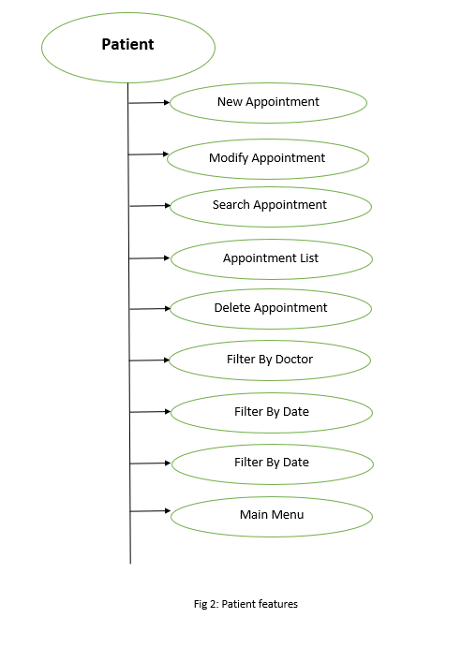

After selecting patient option from main menu we will come to this section. In the Patient Appointment section, users will get six options. They are the following below.

1. **New appointment:**

In this section, users can book new appointments for patients. User will require the patient’s name, phone number, age, gender, disease data to book an appointment. These data will be stored in the system and the system will have a new patient entered into it. The data of the patient is accessible by other features of this system.

1. **Modify existing appointment data:**

Data of an appointment used while booking, can be updated later. This section provides such accessibility to the users. Users can update every type of data of the patients which is stored in the system.

1. **Search appointment data:**

For a system like this, the data of a specific appointment can sometimes be needed. Users can search for the specific appointment data by using the name of the patient. The system will show the searched patient’s entire appointment details if the searched name was used to book any appointment using this system.

1. **List of appointments:**

In this section, all the appointment history can be browsed which was booked using this system. This is a very useful section for users to keep track of a hospitals, consultation centers and diagnostic centers ’s total patient entry. The data is displayed as a list here. In this list, there are all types of data related to the patients.

1. **Delete the entire record:**

This section is used to remove the entire data related to the patients stored in the system. User will have to press any key to administrate this functionality and the data will be removed permanently from the system.

1. **Back to the main menu:**

This is the last section of the patient menu. If the users choose this section, the system will take them back to the main menu of this system.

**Doctor:**

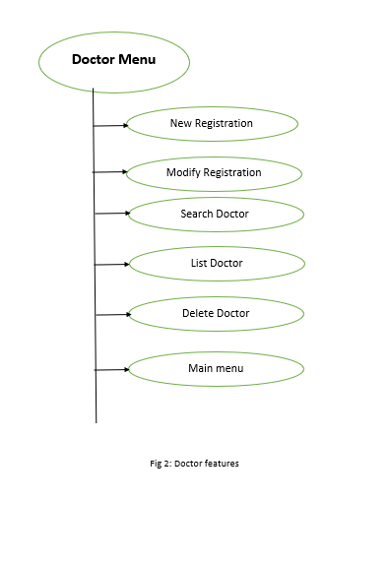

In the Patient Appointment section, users will get five options. They are the following below.

1. **Registration:**

Users can register a new doctor into the system. To register a new doctor into the system, users will have to provide data about the doctor. Required data are the doctor’s name, age, gender, address, educational qualification (as degree) and the department of specialization. Upon providing these data, there will a new doctor registered in the system.

1. **Modify registered doctor’s info:**

Users may fail to submit every data correctly into the system or there may be situations when the doctors may request to update their personal details. This section is used for such situations where the user will get accessibility to update every data of a registered doctor.

**3.Search for a doctor’s info:**

In this section, users can search for a specific doctor’s data by using his/her name that was used while registering. A name is provided by the user which the system will use to run a search. If there is any doctor registered with that name, the system will display his/her data to the user.

**4.List of doctors:**

Upon selecting this section, the system will display all the doctors’ data that will be in the system at that moment. The data will be displayed as a list to the user. Every detail about the registered doctors will be displayed in that list.

**5.Back to the main menu:**

This is the last section of the doctor’s menu. Upon selection,it will take the user back to the main menu.

**Medical Test:**

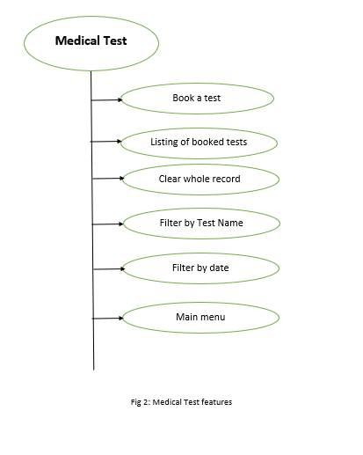

This section is for the clinical lab test for the patients. Users can book tests for the patients. There are six options to choose. They are the following below.

1. **Book a test:**

This is the first section of the medical test menu. Users book appointments for medical tests for the patients. The advice of medical tests is prescribed by a doctor according to which users book appointments for patients. Commonly related data with medical tests are required to book test appointments here.

1. **Listing of booked tests:**

Selecting this option will display all the booked appointments and all their related data in the order they were booked in. This will be displayed as a list. For every single appointment, there will be the name of the patient, the gender, the age, the prescribed advice, the doctor who prescribed the test.

1. **Clear whole record:**

This section is used to remove the entire data related to medical tests stored in the system. User will have to press any key to administrate this functionality and the data will be removed permanently from the system.

1. **Filter by advice:**

Users can filter the appointment list by the prescribed advices. For this purpose, the user will have to provide an advice name which is normally the test name, and the system will show all the appointments with the provided advice in it.

1. **Filter by date:**

Users can filter the appointment list by date. For this purpose, the user will have to provide a date and the system will show all the appointments with the same date stored in it.

1. **Main Menu:**

This is the last section of medical test. Users will go back to main menu through it.

**Methodology and Implementation:**

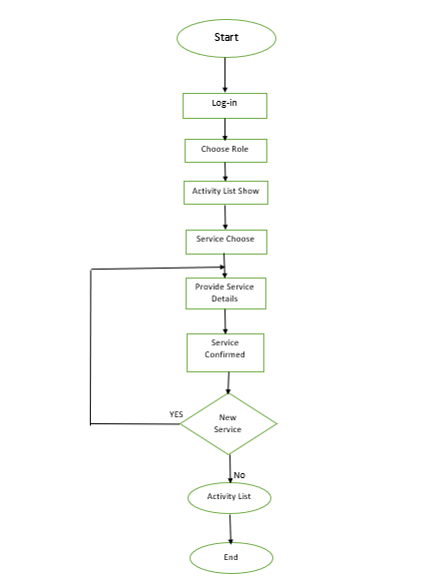Flowchart of the Program:

**Use-Case diagram of Project:**

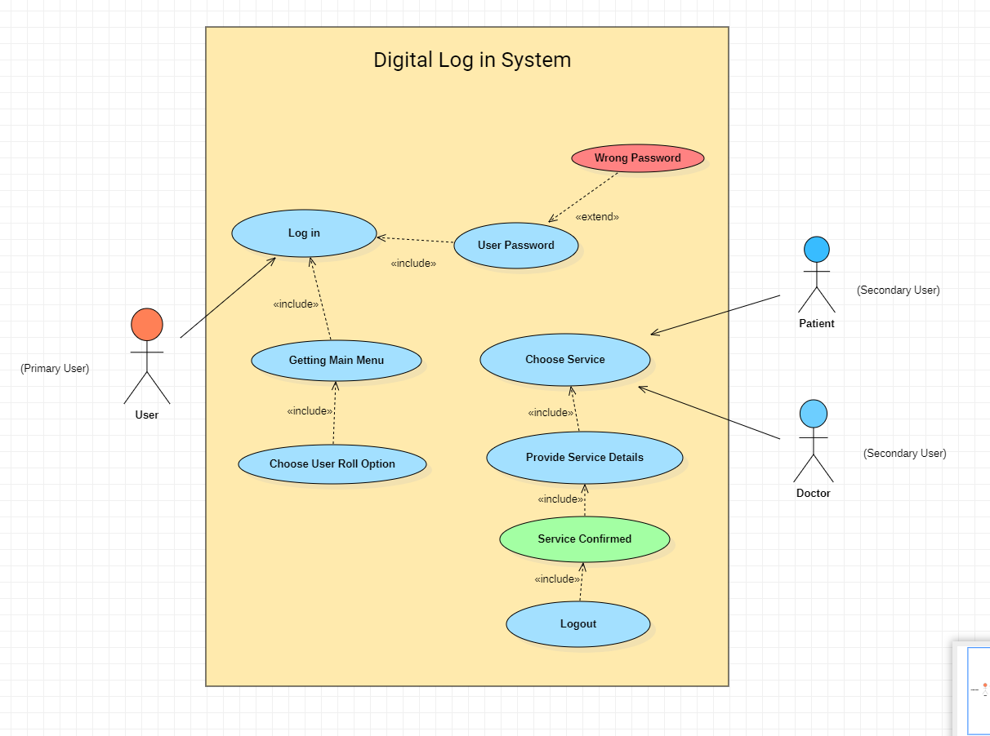

**Project-Implementation:**

This project was implemented using C programming language. Many different features of this language were used to function this program. Among them, conditional statements, loops, goto functions, system function, library function, file I/O, variables of many different data types are mostly common. Here is a detailed analysis of the features down below.

**Login**:

A conditional statement was used to match the entered id and password with the pre- defined id and password. This whole process is being executed inside a loop until system finds a match. Upon match, the system calls another user defined function which takes the user to the main menu.

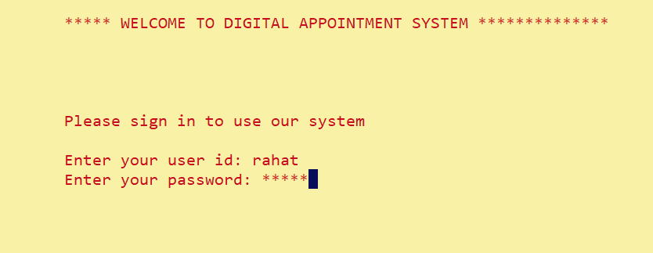

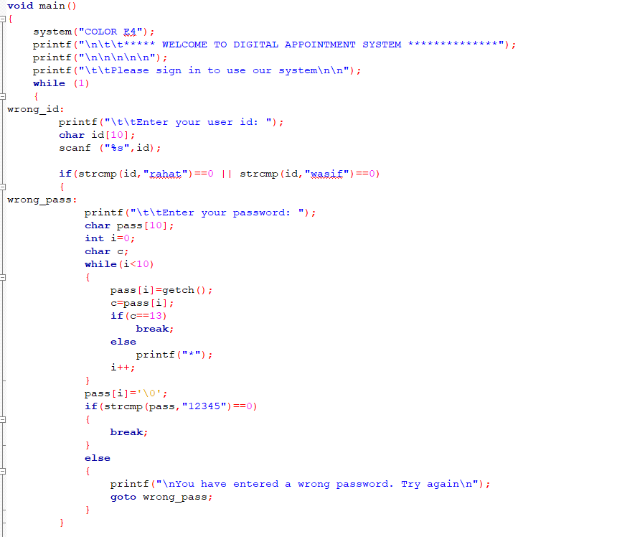

**Choose Role**:

In the main menu, the system will display four sub-menus for the user to choose from. Upon choosing, the system will call the specific function. There is function for each of the sub-menu. This choice input is taken as an input for a switch case where the function is called at. Thus, system will jump to the specific function that is being called and execute the function.

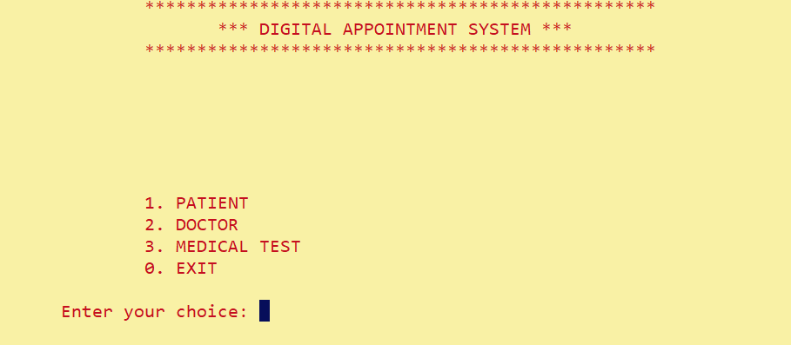

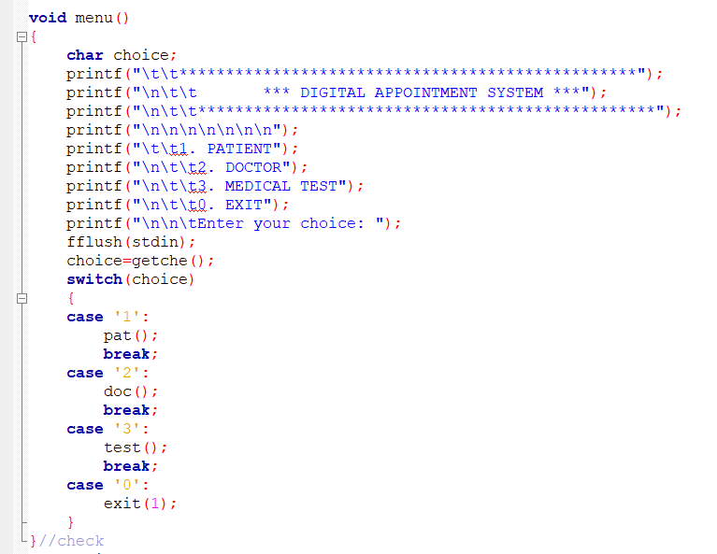

**Activity Show List**:

Upon choosing a sub-menu, the system will call that specific function that is being called by the sub-menu. System will then be printing the activities as a numbered list. User needs to choose an activity which will be taken as an input for a switch case. The cases are activities like entry, update, filter, etc.

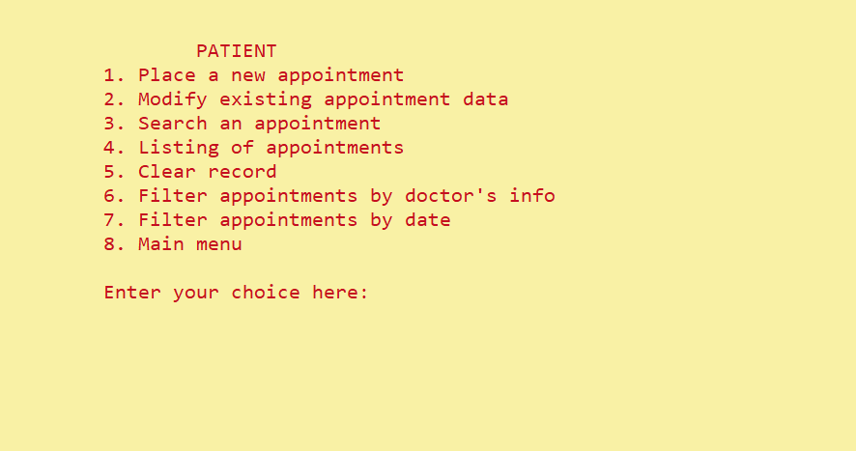

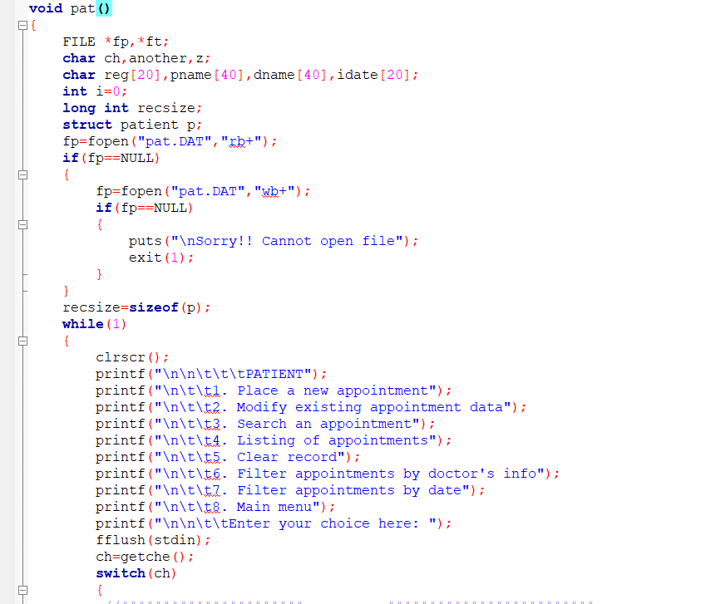

**Service Choose:**

This section comes after choosing an activity from the activity list which will take the user to that chosen switch case statements and execute them accordingly. System may ask for some data which varies for different activities and if provided it will store them in the file that was opened at the main menu.



**Provide Service Details:**

Services for the chosen activities will be displayed after providing data asked by system or sometimes right after choosing the activity. For example, in case of displaying the entire data list, system doesn’t ask for any data. It simply displays the data right after choosing the activity. The part of the program executes by moving the file pointer to the exact data package in the file. System read the data where the file pointer is at and displays them in the console.

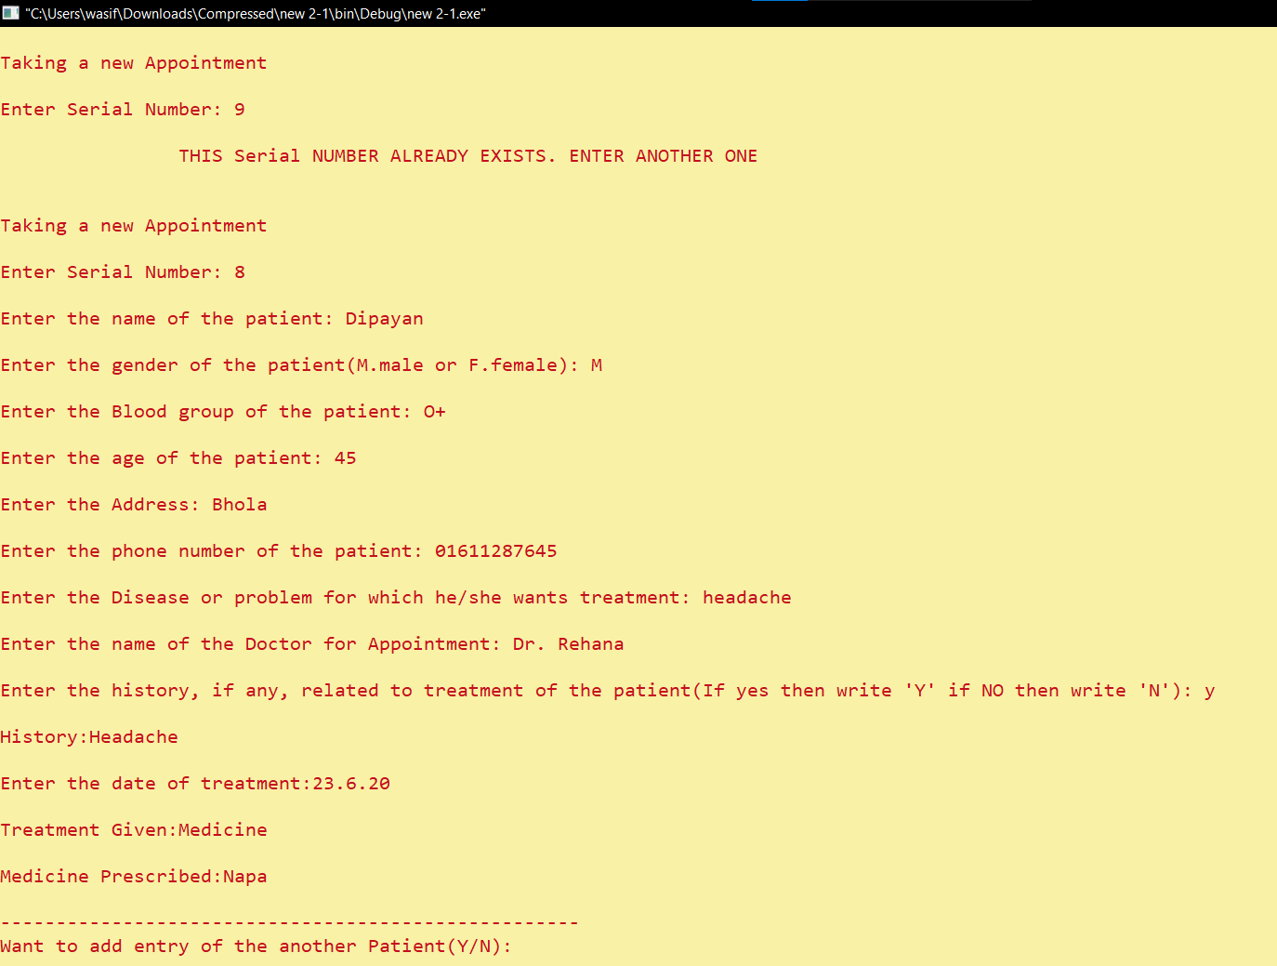

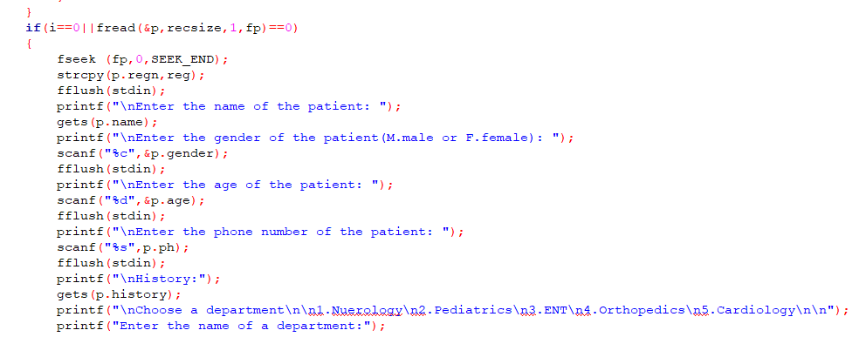

**New Service:**

After executing all the chosen switch case statements, the system will ask the user for a repetition. That is if the user wants to use the same service again. Upon a Y/N statement the program will repeat using a loop or go to the activity list. If it’s a no, then the program goes to the activity list. From this section, user can again choose from activity list or an exit statement that will close all the opened file and close the program.

**Limitations:**

* This system can’t delete a specific appointment record from the list.
* A specific doctor can’t be unregistered on the doctors’ list. It will create a problem when a doctor will resign from a hospitals, consultation centers and diagnostic centers as the list will still show the doctor’s name in it. In such a case, the user will have to re-edit the whole list in order to show appropriate information.
* This application is helpful only on a daily basis work. Further upgradation will make it efficient for monthly basis work.

**Future Possibilities:**

* We hope to update a feature that can be used to delete specific appointment details from the appointment list.
* The same feature can be used to unregister a doctor from the doctors’ list.
* We can update the interface of the application to give it a more lucrative look.

**Conclusion:**

This project can be a nice and easy way for a hospital to manage the appointments’ data. Reducing complications and time consumption during the process is the main motto of this project. This project will get further upgrades in future which will make it a more stable and efficient program.

Hopefully, this system will ensure a smooth and hassle-free appointment experience which will create a more fun to work with environment for the users. Moreover, this system can be a way for a medical institution to integrate in this age of modern technology.

**Breakdown of Responsibilities:**

|  |  |  |
| --- | --- | --- |
| List | Contribution by  Wasif Bin Zahir | Contribution by  Fazle Rabbi Rahat |
| Requirement Specification | **55%** | **45%** |
| Software Design | **45%** | **55%** |
| Coding | **50%** | **50%** |
| Debugging and Testing | **40%** | **60%** |
| Report Preparation | **60%** | **40%** |

**References:**

1. The C Programming Language by Dennis Ritchie
2. https://www.geeksforgeeks.org/c-programming-language/?ref=ghm

**……………………........... …………………**

Signature of Supervisor Date